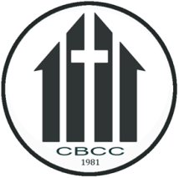
ADVENT SUNDAYS
Convention Baptist Center Church
Purok 2, Gilda Subd., Guihing,
Hagonoy, Davao del Sur

First Advent
Scripture Reading: 1 John 1: 1-5
Candle Lighting: Yellow (Golden Plan of God)

Second Advent
Scripture Reading: Isaiah 9: 2-7
Candle Lighting: Pink (Purity and Sanctification)

Third Advent
Scripture Reading: Jeremiah 33: 14-16
Candle Lighting: Orange (Power and Vigor)

Fourth Advent
Scripture Reading: Micah 5: 2-4
Candle Lighting: Green (Hope)

Final Advent
Scripture Reading: Matthew 2: 9-12
Candle Lighting: White (New Life)

